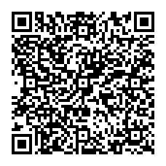
Specification clause for Coral Brush Activ
N10 GENERAL FIXTURES/ FURNISHINGS/ EQUIPMENT
300 ENTRANCE MATTING:

Coral Brush Activ

Product:
10mm Coral Brush Activ in colour .............. Supplied and installed or supplied only from Syncros Entrance Matting Systems, (FESSI certified) Triumph Way, Kempston, Beds, MK42 7QB, and Tel. 01234 314314 / Fax 01234 314306 / E-mail: sales@syncros.co.uk in accordance with the manufacturer’s installation details.

Product reference: Coral Brush Activ
Coral Brush Activ FR

Colour/ pattern: (delete as appropriate)

5830 black | 5821 grey | 5856 chocolate | 5814 teak
5810 anthracite | 5801 graphite | 5836 mocha | 5834 marble
5850 black lines | 5841 grey lines | 5846 chocolate lines | 5844 teak lines
5827 marine | 5802 lagoon | 5806 rust | 5824 coir
5847 marine lines | 5805 aquamarine | 5866 rust lines | 5804 raffia
5808 forest | 5828 lime | 5823 red | 5833 orange
5843 purple lines

